Please RSVP to Bonnie in church office asap or let her know if you did not yet receive an invitation!

Program for Volunteer Honour and Celebration Night – Friday, May 3, 2019, 6:00 to 9:00 p.m.
6:00 p.m. to 6:30 p.m. Punch Reception and Hors d’oeuvre Appetizers
6:30 p.m. to 6:45 p.m.
Opening Worship Number with Brendyn Dyck Worship Team
Greetings from Myron Dyck, Mayor of Niverville
Greetings from Jason Kehler, Chairman of Niverville Ministerial
Blessing
6:45 p.m. to 7:45 p.m.
Catered Banquet Meal will be Served
7:45 p.m. to 8:00 p.m.
Clare and Roger to express words of appreciation
Presentation of Gifts to all Volunteers
Presentation of Plaque Award to Ken Isaak for Recognition of Long and Faithful Service
8:00 p.m. to 8:20 p.m.
Worship Set with Brendyn Dyck and Worship Team
8:20 p.m. to 9:00 p.m. (or longer, depending on ministry duration with gentle worship music in background)
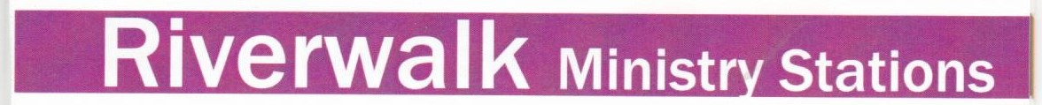
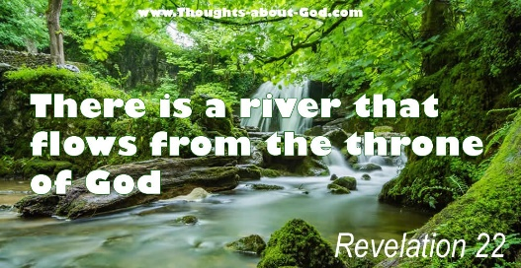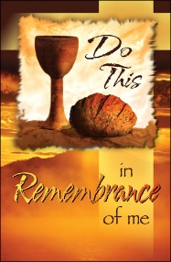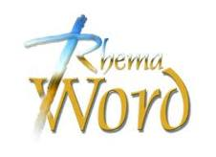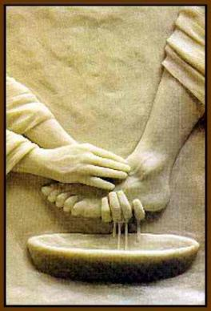
- Rhema Word – Come, receive a Rhema Word from Scripture that is under the anointing of the Holy Spirit.
- Prophetic Ministry – Come, receive an encouraging word from the Lord and be refreshed by what He is speaking over you.
- Prophetic Flagging and Dance – Receive ministry from the Lord through flagging and dance.
- Prophetic Art – A place to express your heart through painting as a form of worship to the Lord.
- Foot Washing – Come and receive Christ’s physical expression of love and service towards us through having your feet washed.
- Communion – A place to take self-serve Communion to receive the resurrection life paid for and reflect on the incredible love that God has for you.
- Healing Room – Receive prayer ministry for your physical body or for a hurting heart and allow the Holy Spirit to bring healing and restoration.

The River Walk Stations are Self-Directed and Every Station is Optional to Participate In.

